**SonarQube**

**SonarQube** is an open-source platform developed by SonarSource for continuous inspection of code quality

here it shows code bugs &Vulnerabilities, code smell, Duplications, Size

* **Sustainability** - Reduces complexity, possible vulnerabilities, and code duplications, optimising the life of applications.
* **Increase productivity** - Reduces the scale, cost of maintenance, and risk of the application; as such, it removes the need to spend more time changing the code
* **Quality code** - Code quality control is an inseparable part of the process of software development.
* **Detect Errors** - Detects errors in the code and alerts developers to fix them automatically before submitting them for output.
* **Increase consistency** - Determines where the code criteria are breached and enhances the quality
* **Business scaling** - No restriction on the number of projects to be evaluated
* **Enhance developer skills** - Regular feedback on quality problems helps developers to improve their coding skills

**Installation of SonarQube:**

First create ec2 server

Next let us create MySQL RDS in aws by specifying master user and password,

need to remember user and password

after Creating lets go to security groups of RDS and add private ip of the ec2 Server we have created

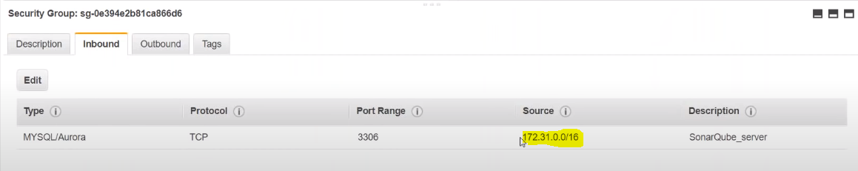

Now login to ec2 user

<https://github.com/ValaxyTech/Simple-DevOps-Project/blob/master/SonarQube/SonarQube_Installation.MD>

all the bellow setup cmd all located in this git link

yum install mysql -y

yum install java-1.8.0-open jdk -y

<https://www.sonarqube.org/downloads/>

download sonarqube-6.0.zip

cd /opt

wget https://sonarsource.bintray.com/Distribution/sonarqube/sonarqube-6.7.6.zip

unzip sonarqube-6.7.6.zip

mv /opt/sonarqube-6.7.6 /opt/sonar

mysql -h <RDS_Instance_endpoint>:3306 -u <DB_USER_NAME> -p <DB_PASSWORD>

this cmd will connect out ec2 server to database

CREATE DATABASE sonar CHARACTER SET utf8 COLLATE utf8_general_ci;

it will create a data base called sonar

CREATE USER sonar@localhost IDENTIFIED BY 'sonar';

it will create local user

CREATE USER sonar@'%' IDENTIFIED BY 'sonar';

it will create remote user

GRANT ALL ON sonar.* TO sonar@localhost;

GRANT ALL ON sonar.* TO sonar@'%';

above two cmd will grant access permission to the users

use mysql

show databases;

SELECT User FROM mysql.user;

FLUSH PRIVILEGES;

QUIT

the above cmd will check users and databases

QUIT

this will quit database and redirect to ec2 server

cd /opt/sonar/conf

vi sonar.properties

before

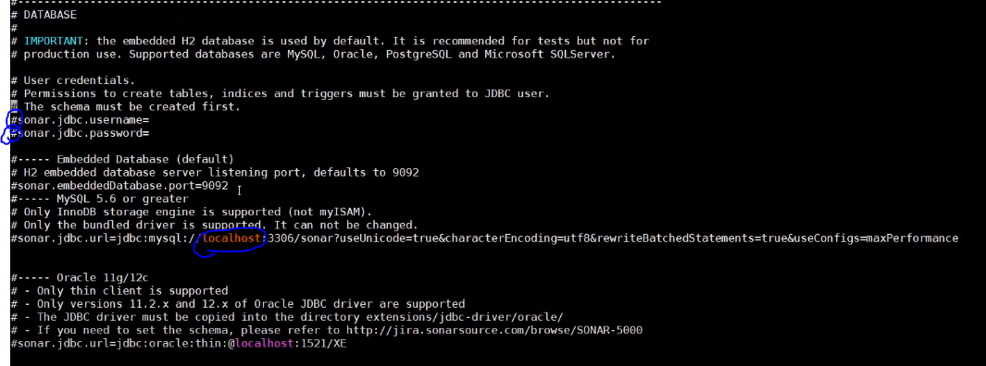

after

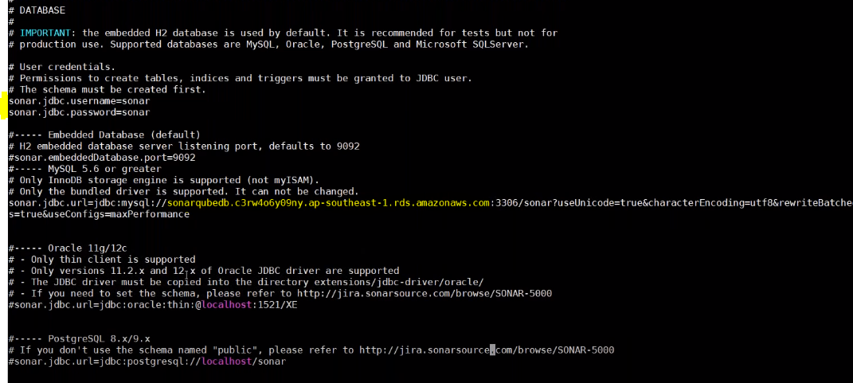

here we should remove comments in the highlighted area

and remove local host and give RDS endpoint in the highlighted area

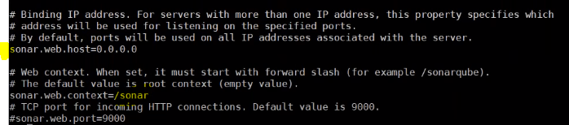

and scroll down to bottom

here we should remove comments in the highlighted area

and give /sonar

cd /opt/sonar/bin/linux-86-64

./sonar.sh start

this will start sonar cube

./sonar.sh status

now lets go to browser

**<ip add>:9000/sonar/**

we can login username and password as admin and admin

**Integrate SonarQube with Jenkins**

need jenkins and sonarqube server should upon running

let start jenkins server

<https://github.com/ValaxyTech/Simple-DevOps-Project/blob/master/SonarQube/Sonar_Integration_with_Jenkins.MD>

all the bellow cmd all located in this git link

need to install sonarqube scanner in the jenkins

wget https://binaries.sonarsource.com/Distribution/sonar-scanner-cli/sonar-scanner-cli-3.3.0.1492-linux.zip

unzip sonar-scanner-cli-3.3.0.1492-linux.zip

mv sonar-scanner-cli-3.3.0.1492-linux /opt/sonar_scanner

vi /opt/sonar_scanner/conf/sonar-scanner.properties

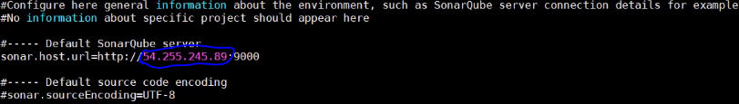

here we need to provide sonarqube server public ip

**login to jenkins in browser**

add a **plugin – SonarQube Scanner**

next go to manage jenkins – configure system – sonarqube server

click on add sonarqube

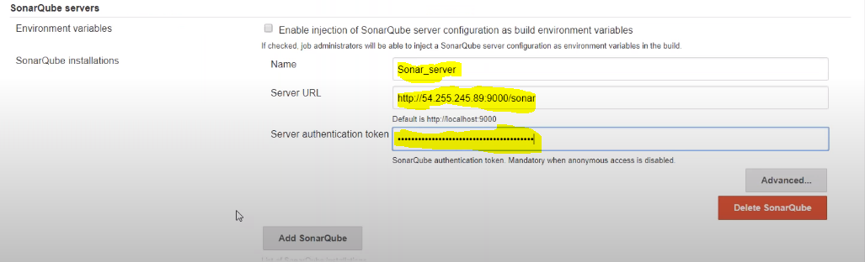

provide name, provide sonarqube server url and

in server authentication token…. here lets go to sonarqube website My Account > Security > Generate Token….. this token needed to paste here and integrate sonarqube with jenkins

next go to manage jenkins – global tool configuration

here in SonarQube Scanner -add sonarqube scanner

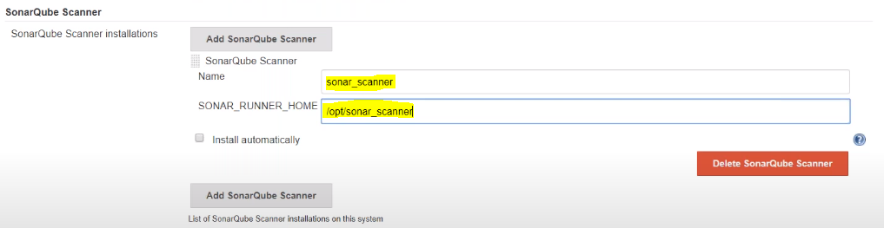

lets add the name and path of sonar from sonarqube server

now lets create a job…. by providing git and in post build actions- select the execute sonarqube scanner

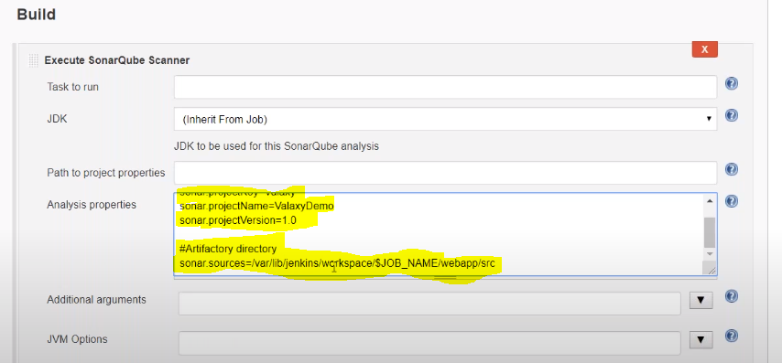

here in Analysis properties we need to add…..

sonar.projectKey=DevOpsProject

sonar.projectName=DevOpsProject

sonar.projectVersion=1.0

sonar.sources=/var/lib/jenkins/workspace/$JOB_NAME/<PROJECT_NAME>/src